Please do not post this final writeup to the course website.

Neurosieve

* A description of the goal of the project.
  + Researchers would like to trace neuron images to get an idea of their morphology and run statistics on them or whatever
  + Generally you have to do this manually by hand under a microscope
    - Which isn’t super accurate
    - Really time consuming
  + Would like to be able to automate it using computer vision
    - This already exists, as tracing algorithms
    - You can take 3d image stacks of a neuron and trace them with algorithm
  + But it’s noisy, and that noise affects the tracing algorithms
  + So we want to use neural networks to perform segmentation on the neuron images and, remove everything that isn’t neuron, and then run the tracing algorithm for hopefully better performance
* A list of students who were part of the project, and what contribution was made by each student.
  + Hasan processed the data
  + Crystal wrote the architecture of the program
  + Puja figured out how to trace it
  + Charu got GPU resources
* A description of which milestones were achieved and which challenges if any were encountered.
  + Hasan got all the data that were originally in v3dpbd and swc files and converted them into npy arrays that were actually usable by us
    - It took a really long time to figure out what format the swc files were in and the standards that the documentation online said they were in were not followed by people who submitted the data to bigneuron which cause a lot of headaches
  + Crystal found a usable architecture that was simple and especially for medical image segmentation and converted it to be usable with 3d images
    - We ended up failing to get a GPU because amazon web services ended up charging us way more money than the amazon educate gave us in money
    - So we ended up using only the 2D algorithm
  + Puja and Charu got the tracing algorithm to work and figured out how to compare accuracies
    - There was no way to get the tracing algorithm to work in batch. You have to use the program written by the owners of BigNeuron, Vaa3D, and download a plugin to use in the GUI that traces only one at a time.
* Figures for results, e.g. performance and confusion matrices of classifiers, images produced for graphics projects, other visualizations, etc.



* Explanations or figures for the architectures of neural networks used (if appropriate)



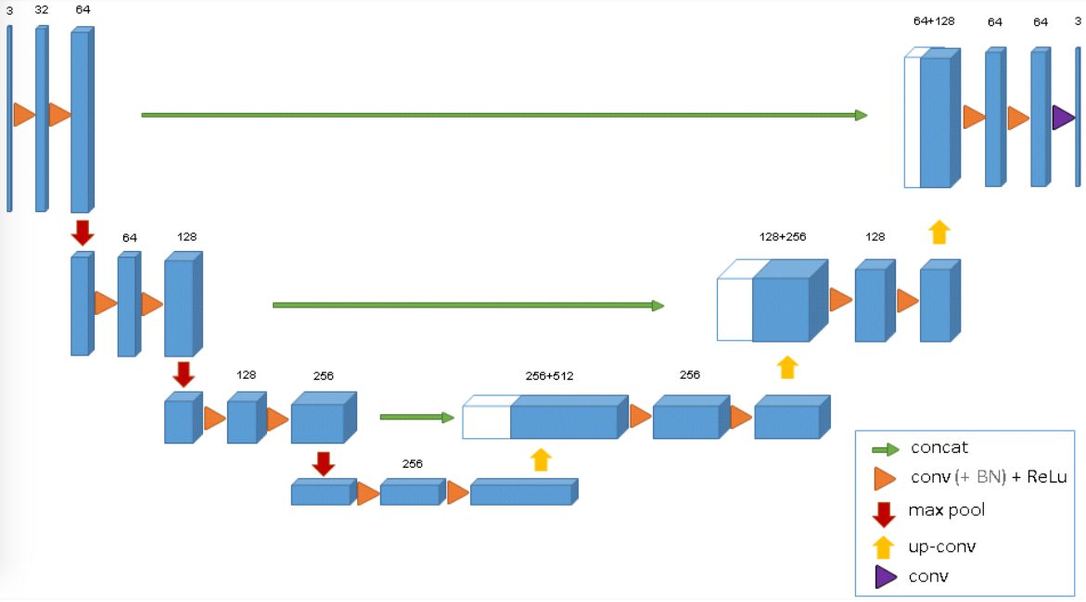

* Any other observations you would like to make.
* 2-4 pages

U-net 2d architecture from O. Ronneberger, P. Fischer, and T. Brox, “U-net: Convolutional networks for biomedical image segmentation,” in MICCAI, pp. 234–241, Springer, 2015.

U-net 3D architecture from O. Cicek, A. Abdulkadir, S.S. Lienkamp, T. Brox, O. Ronneberger, *3D U- Net: Learning Dense Volumetric Segmentation from Sparse Annotation*, 2016, [online] Available: .